System Design

TPS – Throughput Per Second/Request Per Second -> If the request is high then the caching storage is required.

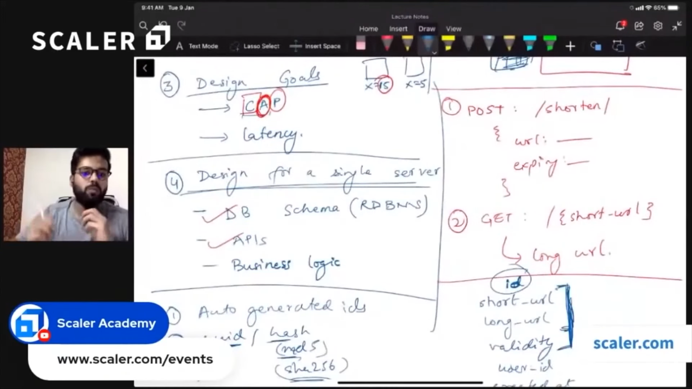


Design a Google search engine typehead

Requirements
a. When a user type something in the URL, it should give a list of suggestions in the dropdown, like top 5.
b. Suggestions should be sorted based on popularity. The most popular should be at the top.
c. Filter words. It should not show pirated or adult type suggestions.
d. Typo handling. It should correct the spelling mistakes or show the closest matches.
e. Personalization using user cookies. E.g. Suppose if two user typed Prime in the URL, then based on user personalization it may suggest Prime time for one and Prime Minister to other.
f. Location based search. It should show the relevant suggestions based on the user's location.

Design Goal
a. CAP theorem ->
1. Availability and Partition (AP) are required. This means that the system should be able to handle network failures and still serve the requests.
2. Eventual Consistency -> Top 5 need not be consistent or accurate data but Availability is a must. This means that the system can tolerate some delay in updating the popularity of the suggestions, if they are eventually updated.
b. Scale Estimation -> Based on active user, suppose 1B makes 1 query request per day. This means that the system should be able to handle a high volume of requests per second.

Data Structure
a. Trie DS is used to design a search engine typehead. A Trie is a tree-like data structure that stores words in a hierarchical way. Each node in the Trie represents a character, and each path from the root to a leaf represents a word. For example, the words "cat", "car", and "cart" can be stored in a Trie as shown below.
[Diagram of a Trie with root node as empty, and three paths for "cat", "car", and "cart"]
Here is a diagram of a Trie with root node as empty, and three paths for "cat", "car", and "cart":
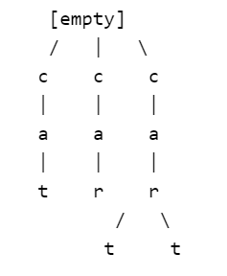
Each node in the Trie represents a character, and each path from the root to a leaf represents a word. The Trie allows us to efficiently search for a prefix and get all the words that start with that prefix. For example, if we search for "ca", we can get "cat", "car", and "cart" as suggestions.

The Trie allows us to efficiently search for a prefix and get all the words that start with that prefix. For example, if we search for "ca", we can get "cat", "car", and "cart" as suggestions. To store the popularity of each word, we can also store a frequency value at each leaf node. For example, if "cat" is more popular than "car", we can store a higher frequency value for "cat" than "car". This way, we can sort the suggestions based on their frequency values.

Problems with only using Trie DS
a. Storage. A Trie can take a lot of space, especially if the words are long and have many common prefixes. For example, if we have words like "application", "apple", "apply", "appliance", etc., we will have a lot of nodes for the prefix "app". To reduce the space complexity, we can use a compressed Trie, which merges the nodes that have only one child. For example, the words "application", "apple", "apply", and "appliance" can be stored in a compressed Trie as shown below.
[Diagram of a compressed Trie with root node as empty, and four paths for "application", "apple", "apply", and "appliance"]
Here is a diagram of a compressed Trie with root node as empty, and four paths for "application", "apple", "apply", and "appliance":
[empty]
|
app
|
/ | \
l l l
/ | \
i y e
/ | \
c | a
/ | \
a | n
| \
| c
| \
| e
|
|
i
\
c
\
a
\
t
\
i
\
o
\
n
In a compressed Trie, nodes that have only one child are merged to reduce the space complexity. For example, the words "application", "apple", "apply", and "appliance" can be stored in a compressed Trie as shown above.
Additionally, we can use consistent hashing to distribute the Trie across multiple machines. Consistent hashing is a technique that assigns each node in the Trie to a point on a circular hash ring and maps each machine to a range of points on the ring. This way, when a new machine is added or removed, only a small fraction of nodes needs to be transferred to maintain the balance of the ring. Consistent hashing can improve the scalability and availability of the Trie, as well as reduce the network latency for accessing the nodes. To implement consistent hashing, we can use a hash function that maps each node's key (the word or prefix) to a 32-bit integer, and then assign the node to the nearest machine clockwise on the ring. The machine can store the node's value (the frequency) along with the key. When a read or write operation is performed on the Trie, we can use the same hash function to locate the machine that stores the node's value, and then update or retrieve it accordingly.

b. Read operation should be >>> Write operation -> Frequency of each word in the Trie will be updated only when the frequency has reached to a specific number, suppose thousand. This data can be stored in a HashMap. This way, we can avoid updating the Trie too frequently, which can be expensive and cause inconsistency. The HashMap can store the word and its frequency as a key-value pair. For example, if "cat" has a frequency of 1000, we can store it as ("cat", 1000) in the HashMap. When the frequency of a word reaches a threshold, we can update the Trie with the new frequency value. This can be done in a batch mode, where we update the Trie periodically with the latest frequency values from the HashMap.

Another way of solving this problem is Sampling.
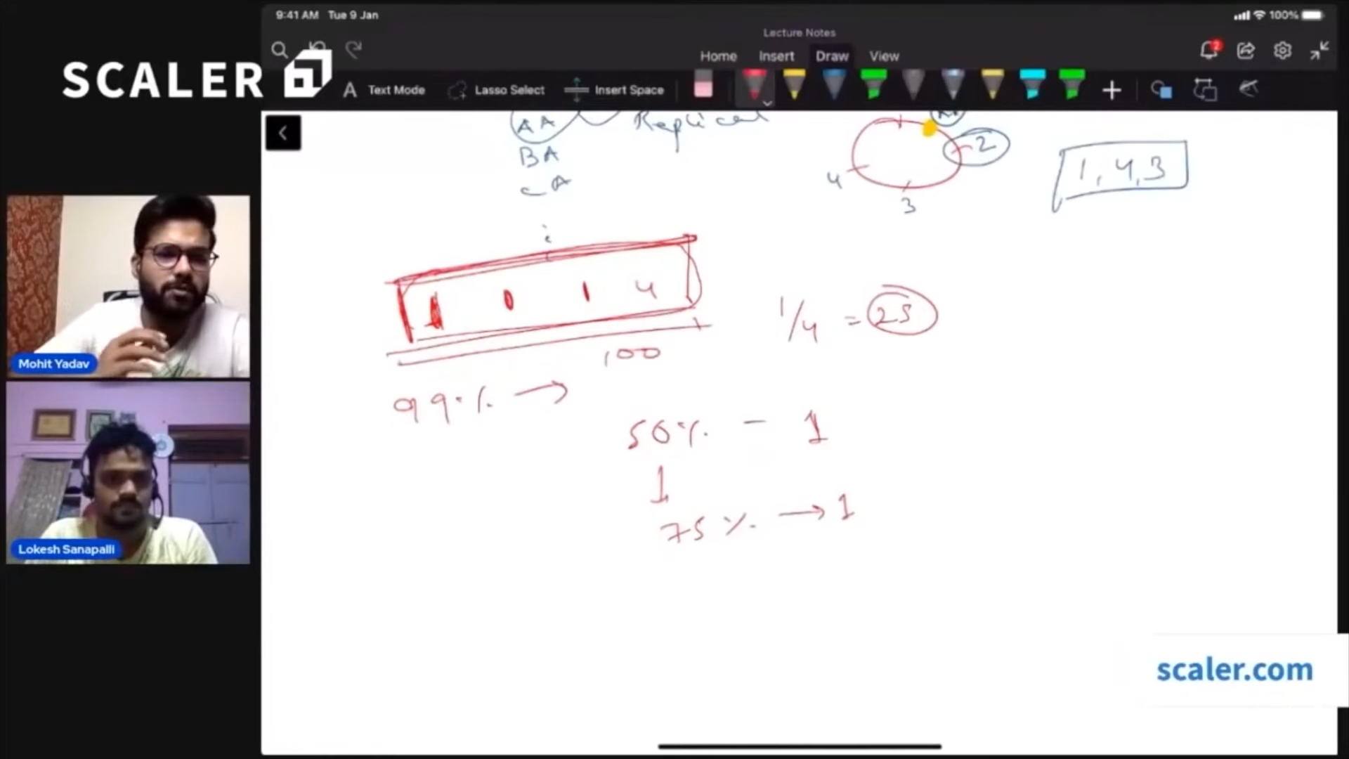
Sampling is a technique that randomly selects a subset of words from the input stream and updates the Trie with their frequency. Sampling can reduce the number of updates to the Trie, as well as the network traffic and storage space required. Sampling can also provide an approximate estimate of the word frequency with high probability, by using a scaling factor that accounts for the sampling rate. For example, if we sample one word out of every 100 words, and we see that "cat" has a frequency of 10 in the sample, we can estimate that "cat" has a frequency of 10 * 100 = 1000 in the whole input stream. Sampling can be implemented by using a hash function that maps each word to a random number, and then selecting the words that have a hash value below a certain threshold.

